**Shashwat Tripathi**

**D10A 58**

**BATCH: C**

**PYTHON LAB**

**Exp No: 3**

**AIM:** Write python programs to understand

A) Classes, Objects, Constructors, Inner class and Static method

B) Different types of Inheritance

C) Polymorphism using Operator overloading, Method overloading, Method

overriding in Python.

**A) CLASSES, OBJECTS, CONSTRUCTORS, INNER CLASS AND STATIC METHOD**

**CODE:**

**Class & Object**

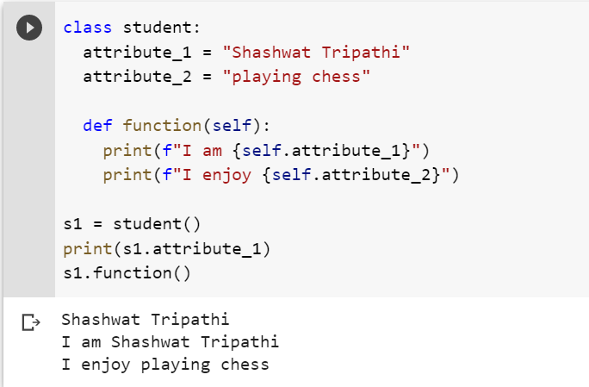

**Constructor**

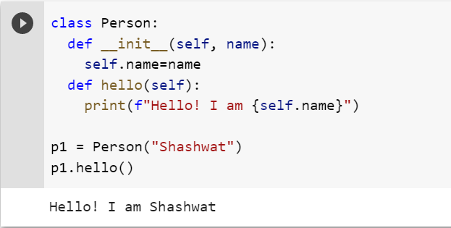

**INNER CLASS**

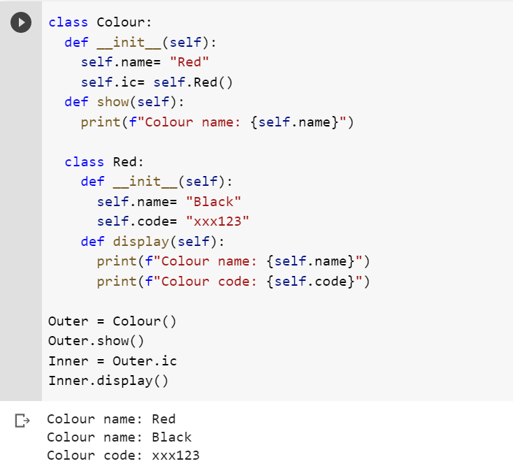

**B) DIFFERENT TYPES OF INHERITANCE**

**CODE:**

**SIMPLE INHERITANCE**

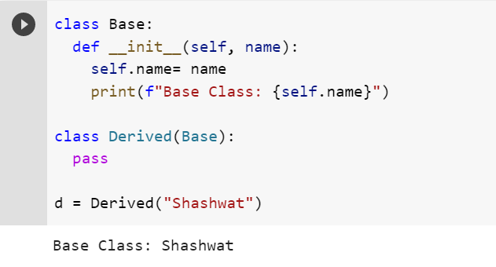

**MULTILEVEL**

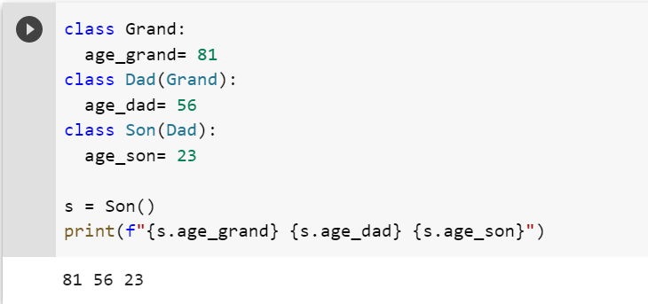

**MULTIPLE**

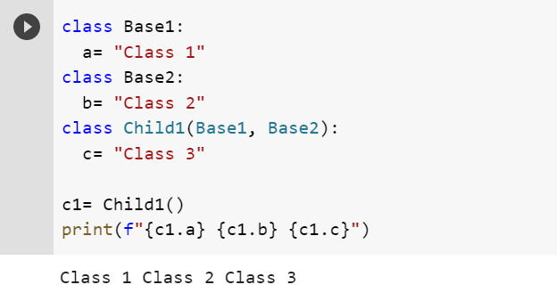

**HIERARCHICAL**

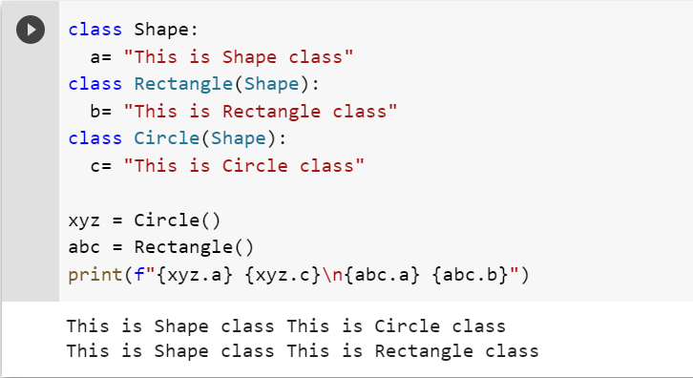

**C) POLYMORPHISM USING OPERATOR OVERLOADING,METHOD OVERLOADING,METHOD OVERRIDING,ABSTRACT CLASS,ABSTRACT METHOD AND INTERFACES**

**CODE:**

**OVERLOADING**

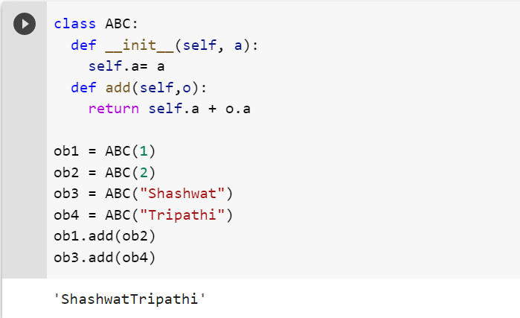

**METHOD OVERLOADING**

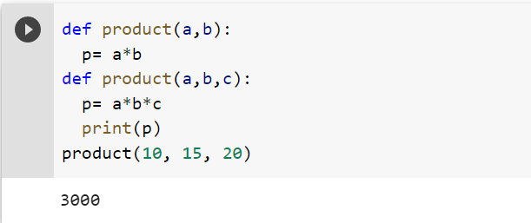

**METHOD OVERRIDING**

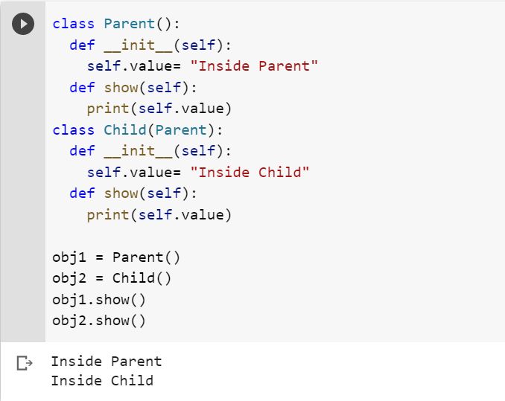

**ABSTRACT CLASS AND METHOD**

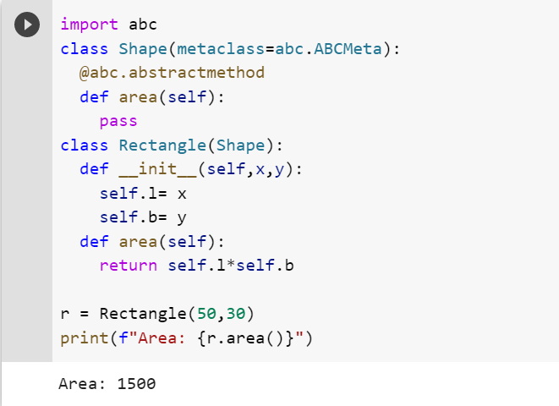

**INTERFACE**

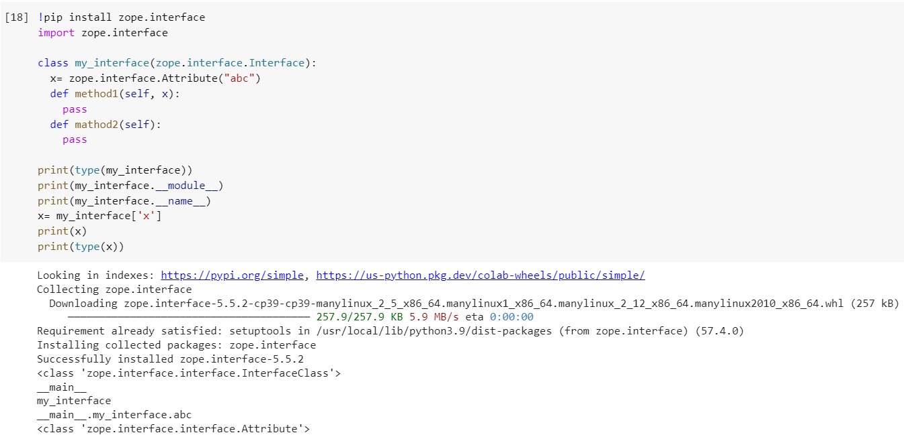

**Conclusion -** Concepts of object-oriented programming were learned and implemented.

Some errors were faced in the abstract method which were resolved later.